

Robotic Process Automation

<Business Process Name>

Process Definition Document (PDD)



Document History

|  |  |  |  |  |  |  |
| --- | --- | --- | --- | --- | --- | --- |
| Date | Version | Role | Name | Organization | Function | Comments |
| dd.mm.yyyy | 1.0 | Author | *Name Surname* | *Client org* | *AP-SME* | Created document v 1.0 |
|  |  |  |  |  |  |  |
|  |  |  |  |  |  |  |

Contents

1. Introduction 4

1.1 Purpose of the document 4

1.2 Objectives 4

1.3 Process key contacts 4

1.4 Minimum Pre-requisites for automation 5

2. As IS process description 5

2.1 Process Overview 5

2.2 Applications used in the process 5

2.3 As IS Detailed Process map 6

2.4 Additional sources of process documentation 7

3. To BE Process Description 8

3.1 TO BE Detailed Process Map 8

3.1.1 Change/Improvement details 8

3.1.2 Areas already automated 9

3.2 In Scope for RPA 9

3.3 Out of Scope for RPA 9

3.4 Business Exceptions Handling 9

3.4.1 Known Exceptions 9

3.4.2 Unknown Exceptions 10

3.5 Application Error and Exception Handling 10

3.5.1 Know Errors or Exceptions 11

3.5.2 Unknow Errors and Exceptions 11

4. Other Requirements and Observations 12

5. Document Approval 12

## Introduction

### Purpose of the document

The Process Definition Document outlines the business process chosen for automation using UiPath Robotic Process Automation (RPA) technology.

The document describes the sequence of steps performed as part of the business process, the conditions and rules of the process prior to automation and how they are envisioned to work after automating it, partly or entirely. This specifications document serves as a base for developers, providing them the details required for applying robotic automation to the selected business process.

### Objectives

The business objectives and benefits expected by the Business Process Owner after automation of the selected business process are:

*{replace the below bullet points that serve as example, with the specific, SMART objectives and benefits expected after automation }*

* *Reduce processing time per item by 80 %. The duration to process an invoice in AS IS state is 7 minutes.*
* *Monitoring of xyz sub activities*

### Process key contacts

The specifications document includes concise and complete requirements of the business process and it is built based on the inputs provided by the **process** **Subject Matter Expert (SME)/ Process Owner.**

The **Process Owner** is expected **to review it and provide signoff for accuracy** and completion of the steps, context, impact and complete set of process exceptions.

The names have to be included in the table below.

|  |  |  |  |
| --- | --- | --- | --- |
| *Role* | *Name* | *Contact details*  *(email, phone number)* | *Notes* |
| ***Process SME*** | *Name, Surname* | [Name.surname@domain.com](mailto:Name.surname@domain.com)  *Mobile: 44 0735 325 209* | *Point of contact for questions related to business exceptions and passwords* |
| ***Process Reviewer /*** | *Name, Surname* | [Name.surname@domain.com](mailto:Name.surname@domain.com)  *Mobile: 44 0735 325 209* | *Point of Contact for process exceptions* |
| ***Process Owner/ Approver for production*** | *Name, Surname* | [Name.surname@domain.com](mailto:Name.surname@domain.com)  *Mobile: 44 0735 325 209* | *Escalations, Delays,* |

### Minimum Pre-requisites for automation

1. Filled in Process Definition Document
2. Credentials (user ID and password) required to logon to machines and applications
3. Test Data to support development.

## As IS process description

### Process Overview

General information about the process selected for RPA prior to automation.

|  |  |  |
| --- | --- | --- |
| # | Item | Description |
| 1 | **Process full name** | *NPO invoice posting* |
| 2 | **Process Area** | *Accounts Payable* |
| 3 | **Department** | *Finance and Accounting* |
| 4 | **Process short description**  (operation, activity, outcome) | *PDF invoices sent by email are posted in SAP for later payment.* |
| 5 | **Role(s) required for performing the process** | *AP Process Associate, AP Payment team etc* |
| 6 | **Process schedule and frequency** | *Daily, Monday to Friday, 9 am – 6 pm* |
| 7 | **# of items processes /month** | *~4500* |
| 8 | **Average handling time per item** | *7 min* |
| 9 | **Peak period (s)** | *End of month, usually from 20th to 28th day of each month* |
| 10 | **Total # of FTEs supporting this activity** | *10* |
| 11 | **Level of exception rate** | *~20% exceptions (incomplete invoice details, unreadable data on the invoice etc)* |
| 12 | **Input data** | *PDF attachments received by email* |
| 13 | **Output data** | *Invoice posted in SAP. Confirmation email. Processed email moved to process folder.* |
| 14 | **Dependencies**  (upstream, downstream) | *n/a* |

*\*Add more table rows if necessary to include relevant data for the automation process. No fields should be left empty. Use “n/a” for the items that don`t apply to the selected business process.*

### Applications used in the process

The table includes a comprehensive list all the applications that are used as part of the process automated, at various steps in the flow.

|  |  |  |  |  |  |  |
| --- | --- | --- | --- | --- | --- | --- |
| # | Application name & version | System  Language | Login Module | Interface | Environment/  Access method | Comments  (Include URLs) |
| *1* | *Outlook 2011* | *EN* | *n/a* | *Client* | *Local desktop* | *Single Sign On* |
| *2* | *SAP 740*  *Patch 11* | *EN* | *ECE* | *Client* | *Local desktop* | *Test environment for POC identical with production system.* |

*\*Add more table rows to include the complete list of applications.*

### As IS Detailed Process map

This chapter depicts the AS IS business process in detail to enable the developer to build the automated process.

*{Detailed process map to be added here, with input/output flow at each stage. Divide the process into stages if required (for better readability)}.*

*Add the AVG TAT (Average Turn Around Time) for each key transaction/ activity. Use the “Short description of key process steps” . More detailed information can be documented in a separate table and/or documented and embedded in this document/ Section.*

*Example:*

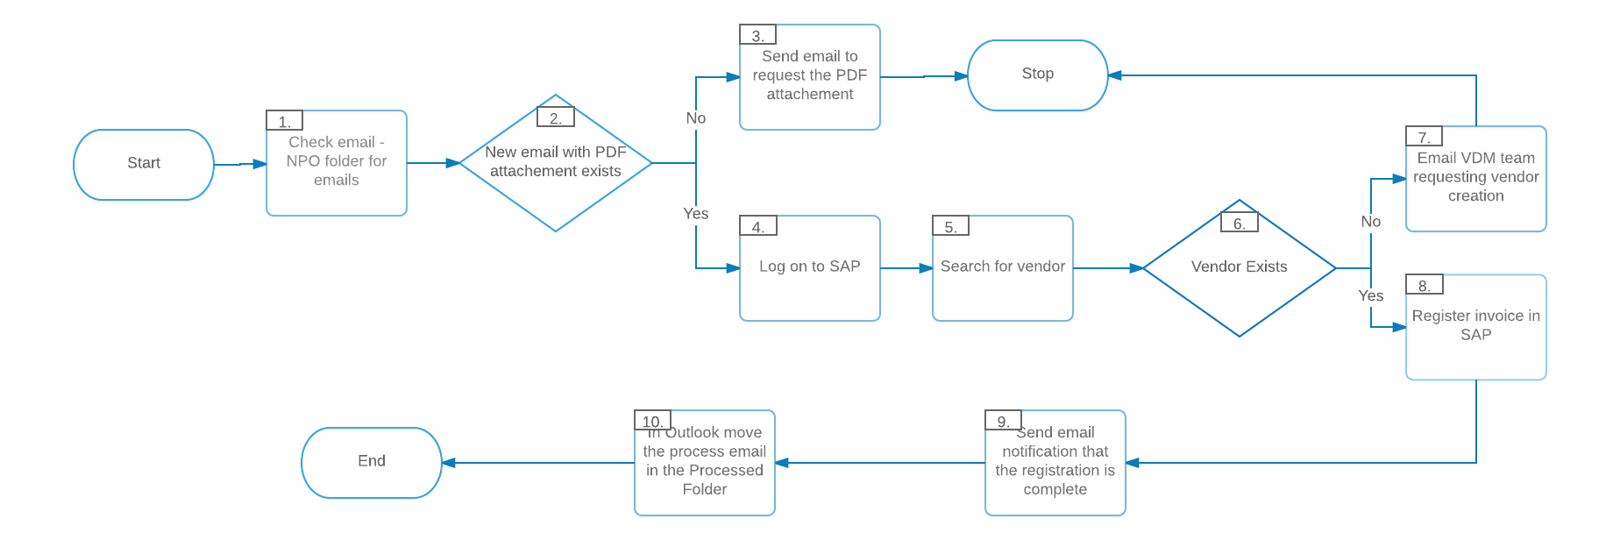

*{Fill in the table below with a short description of the process steps presented in the AS IS diagram}.*

|  |  |  |
| --- | --- | --- |
| Step | **Short Description of Key Process Steps** | **AVG**  **TAT\*** |
| ***1*** | *Check Outlook email, NPO Folder, for new emails to be processed* |  |
| ***2*** | *Pick new email, check the email for attachment and available information* |  |
| ***3*** | *If the PDF attachment is missing, reply to email requesting for the PDF to be sent attached* |  |
| ***4*** | *Logon to SAP, module ECC, navigate to menu* |  |
| ***5*** | *Search for the vendor name listed on the invoice* |  |
| ***6*** | *Check if the vendor entry exists in SAP* |  |
| ***7*** | *If the vendor doesn`t exist, send email to request for vendor entry to be created* |  |
| ***8*** | *If the vendor exists, proceed to register the invoice in SAP* |  |
| ***9*** | *After the invoice is processed, send an email notification that the action is complete* |  |
| ***10*** | *In Outlook, move the email with the processed attachment to the “Processed” folder* |  |

*In the AVG TAT ( Average Turn Around Time) please fill in the current TAT of each transaction. More detailed information can be documented in a separate table and/or documented and embedded below.*

### Additional sources of process documentation

If there is additional material created to support the process automation please mention it here, along with the supported documentation provided.

|  |  |  |
| --- | --- | --- |
| Additional Process Documentation | | |
| **Video Recording of the process [Mandatory]** | *Insert link to the video recording and provide access to the video.* | *Date and time of the recording.*  *Insert additional relevant comments* |
| **List of supporting documents** | *Embed documents* | *List here all the templates, mapping tables, list of URLS that are provided as supporting info for automation.* |
| **Standard Operating Procedure (s)**  **(Optional)** | *Insert link to the standard operating procedure related to the process in scope.* | *Insert any relevant comments* |
| **Other documentation**  **(Optional)** | *Insert link to any other relevant process documentation (L4, L5 process description, fields mapping files etc)* | *Insert any relevant comments* |

*\*Add more table rows to reflect the complete documentation provided to support the RPA process.*

## To BE Process Description

This chapter highlights the expected design of the business process after automation.

### TO BE Detailed Process Map

*{Detailed process map to be added here, with input/output flow at each stage. Divide the process into stages if required (for better readability)}.*

*Example:*

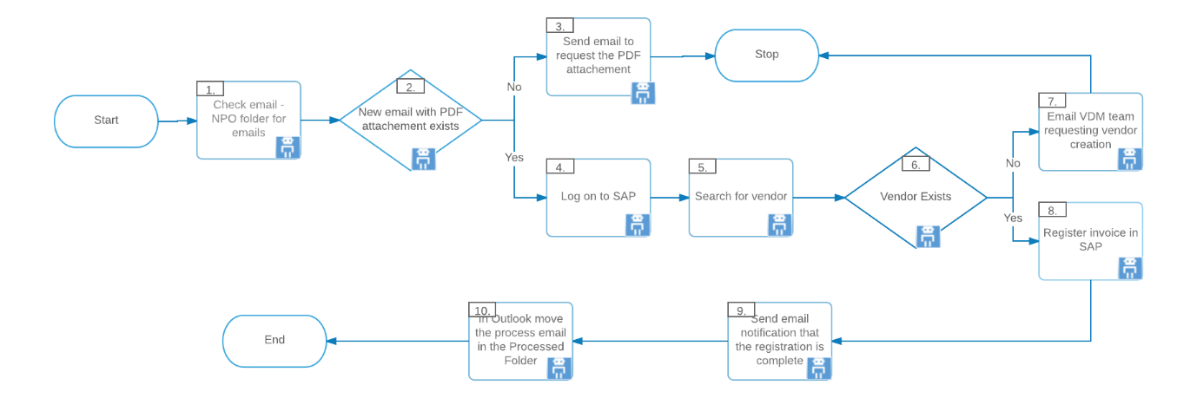

*{Fill in the table below with a legend of the process steps and symbols presented in the TO BE diagram}.*

|  |  |
| --- | --- |
| Legend |  |
| https://documents.lucidchart.com/documents/819ed6e9-92ca-4bb5-a252-ae163eefa005/pages/0_0?a=329&x=338&y=177&w=45&h=24&store=1&accept=image%2F*&auth=LCA%200c7feee77c46d7c6c69488f11cbe96f19bf0594e-ts%3D1493894635 | Step number in the process. Referred in the details or Exceptions and Errors table |
| https://documents.lucidchart.com/documents/819ed6e9-92ca-4bb5-a252-ae163eefa005/pages/0_0?a=329&x=999&y=380&w=43&h=39&store=1&accept=image%2F*&auth=LCA%20244af2796a97c79ad184dd5f891d199a5aaaa18e-ts%3D1493894635 | This process step is proposed for automation |
|  | This process step remains manual (to be performed by human agent) |
|  | Change/ Improvement opportunity |
|  | Area or Branch Already Automated |

### Change/Improvement details

Use this section to detail the list the change or improvement opportunity in the To-Be Process.

Important aspects to be mentioned: what is the initiative, expected outcome, expected completion date, contact person for details, and if will impact the current automation request.

|  |  |  |  |  |  |
| --- | --- | --- | --- | --- | --- |
| # | Initiative name and Expected Outcome/Benefits | Process Step(s) where it is identified | Does it impact the current automation request? How? | Expected completion date | Contact person for more details |
| 1. |  |  |  |  |  |
| 2. |  |  |  |  |  |
| 3. |  |  |  |  |  |

### Areas already automated

List the areas and branches where the process is already automated. Mention if that has any impact on the current automation request.

### In Scope for RPA

The activities **in scope of RPA**, are listed here:

*Example:*

1. *Verify emails for attachments*
2. *Handle exception if attached PDF is missing*
3. *Post data in SAP*
4. *Send confirmation email*

### Out of Scope for RPA

The activities **OUT of scope of RPA**, are listed here. Mention of the changes/ improvement opportunities identified for automation are out of scope for this automation iteration.

*Example:*

1. *Dispatching the emails into NPO invoices folder*
2. *E-invoicing*
3. *Invoices received by Fax*

### Business Exceptions Handling

The Business Process Owner and Business Analysts are expected to document below all the business exceptions identified in the automation process. These can be classified as:

|  |  |
| --- | --- |
| Known | Unknown |
| Previously encountered. A scenario is defined with clear actions and workarounds for each case. | New situation never encountered before. It can be caused by external factors. Cannot be predicted with precision, however if it occurs, it must be communicated to an authorized person for evaluation. |

#### Known Exceptions

The table below reflects all the business process exceptions captured during the process evaluation and documentation. These are **known exceptions,** met in practice before. For each of these exceptions, define a corresponding expected action that the robot should complete if it encounters the exception.

|  |  |  |  |  |
| --- | --- | --- | --- | --- |
| **BE #** | **Exception name** | **Step** | **Parameters** | **Action to be taken** |
| ***1*** | *Missing attachment* | *Step # 2* | *If attachment is missing* | *send email by using* ***Reply email*** *function*  *“Hello,*  *The current email is missing the invoice in PDF/ XML format. Please resend the email with the correct file attached.*  *Thank you”* |
| *2* | *Invoice mandatory details are missing or incomplete (unidentifiable)* | *Step # 3* | *Fields missing or incomplete:*  *Company name*  *Invoice date*  *Invoice reference number*  *Description*  *Taxable amount*  *Tax Rate*  *Total amount*  *Contact information* | *send email for additional details:* ***Reply email***  *“Hello,*  *The product details mentioned in the invoice are incomplete or missing. Please check the invoice details and re-send the correct invoice.*  *Thank you”* |
| *3* | *Vendor does NOT exist in SAP* | *Step # 6* | *Vendor name not found* | *Send email to* [*vendormasterdata@sapvmd.domain.com*](mailto:vendormasterdata@sapvmd.domain.com)  *“Hello ,*  *The vendor presented in the attached invoice is missing from SAP. Please create one entry for it and confirm when it has been done. Thank you,”* |

*Insert more table rows if necessary to capture all the exceptions in a comprehensive list.*

#### Unknown Exceptions

For all the other **unanticipated or unknown business (process) exceptions**, the robot should:

*{Define a corresponding expected action that the robot should complete if it encounters unknown exception.}*

*Example:*

* *send an email notification at* [*XYZ@domain.com*](mailto:exceptions.invoiceprocessing@domain.com) *[insert full name, function and email address] with the original email and error message screenshot attached.*

### Application Error and Exception Handling

A comprehensive list of all errors, warnings or notifications should be consolidated here with the description and action to be taken, for each, by the Robot.

Errors identified in the automation process can be classified as:

|  |  |  |
| --- | --- | --- |
| Area | Known | Unknown |
| **Technology/**  **Applications** | Experienced previously, action plan or workaround available for it. | New situation never encountered before, or may happened independent of the applications used in the process. |

#### Know Errors or Exceptions

The table below reflects all the errors identifiable in the process evaluation and documentation.

For each of these errors or exceptions, define a corresponding expected action that the robot should complete if it is encountered.

|  |  |  |  |  |
| --- | --- | --- | --- | --- |
| **AE #** | **Error name** | **Step** | **Parameters** | **Action to be taken** |
| ***1*** | *Email stops responding* | *Any step when working with outlook. Most frequent when opening attachments.* | *Error message* | *Wait for application to respond.*  *Retry.*  *Close application and run the sequence again.* |
| ***2*** | *SAP logon failure* | *Step 4* | *Account deactivated* | *Send email with screenshot to RPA supervisor.* |

*Insert more table rows if necessary to capture all the exceptions in a comprehensive list.*

#### Unknow Errors and Exceptions

For all the other **unanticipated or unknown application exceptions/errors**, the robot should:

*{Define a corresponding expected action that the robot should complete if it encounters an error or unknown exception.}*

*Example:*

* *send an email notification at* [*XYZ@domain.com*](mailto:exceptions.invoiceprocessing@domain.com) *[insert full name, function and email address] with the original email and error message screenshot attached.*

## Other Requirements and Observations

Include below any other relevant observations you consider needed to be documented here.

*Example: Specific Business monitoring requirements (audit and reporting) etc*

## Document Approval

This document requires serial approval (sign off) from the roles defined in the table below.

Changes to the requirements must be documented in an updated version (i.e v 2.0) and requires a new signature flow.

|  |  |  |  |  |  |
| --- | --- | --- | --- | --- | --- |
| Version | Flow | Role | Name | Organization  (Dept.) | Approval Date: |
| **1.0** | **Document prepared by** | ***Technical Solution Architect*** | *Name Surname* |  |  |
| **1.0** | **Document Approved by:** | ***Process Owner*** | *Name Surname* |  |  |
| **1.0** | **Document Approved by:** | ***Operations*** | *Name Surname* |  |  |
| **1.0** | **Document Approved by:** | ***Compliance*** | *Name Surname* |  |  |
| **1.0** | **Document Approved by:** | ***RPA Architect/ Developer*** | *Name Surname* |  |  |